# Module 2

**Advanced CNNs in Keras**

**Introduction to Transpose Convolution**

## 📌 Transpose Convolution

Transpose convolution — also known as **deconvolution** — is a critical operation used in deep learning for **increasing spatial resolution** within image-based neural networks. It serves as the **inverse of the convolution operation**, and is frequently used for **image generation**, **super-resolution**, and **semantic segmentation**.

### 🔹 What Is Transpose Convolution?

In standard convolution, a kernel slides over the input feature map to **reduce spatial dimensions** and extract meaningful features.

While this down-sampling is essential for recognition tasks, some applications require the opposite — **up-sampling** the input to produce **higher-resolution outputs**.

Transpose convolution addresses this need by:

* **Expanding** the spatial dimensions of the input
* Performing an **inverse convolution operation**
* Producing an **up-sampled feature map** that preserves structural characteristics of the original input

**Common Applications:**

Transpose convolutions are essential in models and systems that require **spatial reconstruction** or **pixel-level predictions**:

* **Generative Adversarial Networks (GANs)**  
  Used to generate high-resolution images from latent vectors.
* **Image Super-Resolution**  
  Enhances the resolution of low-quality images.
* **Semantic Segmentation**  
  Used to up-sample feature maps for **pixel-wise classification**, often producing detailed masks.

### 🔹 How Transpose Convolution Works

The process involves two key steps:

1. **Zero Insertion**  
   Zeros are inserted between elements of the input feature map to **expand the spatial dimensions**.
2. **Convolution Over Expanded Input**  
   A standard convolution is then applied over the zero-inserted feature map using a defined kernel. This process fills in the gaps and generates a **larger output** with learned patterns.

This approach increases the resolution while retaining learned representations from lower-resolution input.

### 🔹 Implementing Transpose Convolution in Keras

To implement a transpose convolution layer in Keras, follow a simple model construction pattern:

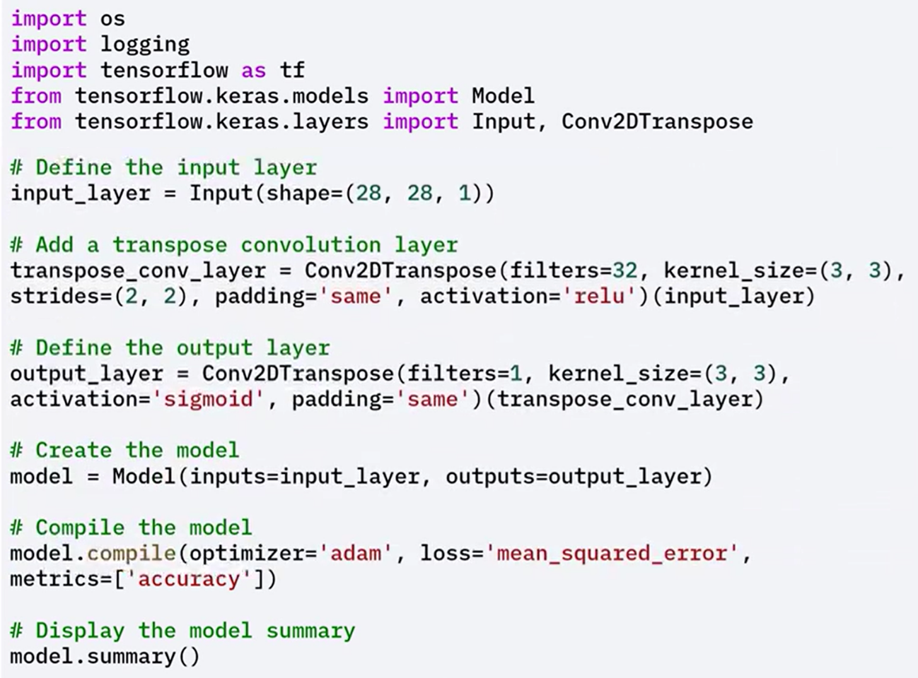

### ⚠️ Best Practices and Pitfalls

**Checkerboard Artifacts**

A known issue with transpose convolution is the appearance of **checkerboard artifacts**, which arise due to uneven overlap of kernel applications during up-sampling.

These artifacts can affect visual quality and prediction accuracy.

**Mitigation Strategy**

To reduce these effects, apply the following approach:

1. Use **UpSampling2D** to increase spatial dimensions smoothly (e.g., by a factor of 2)
2. Follow it with a **standard Conv2D layer** to refine the output

This two-step method often yields better visual quality and reduces unintended noise patterns.

Let's see an example where we reduce the artifacts and improve the quality of the up-sampled images.

In this example, up-sampling 2D performs up-sampling by a factor of two, and applies a convolution layer to refine the up-sampled output.

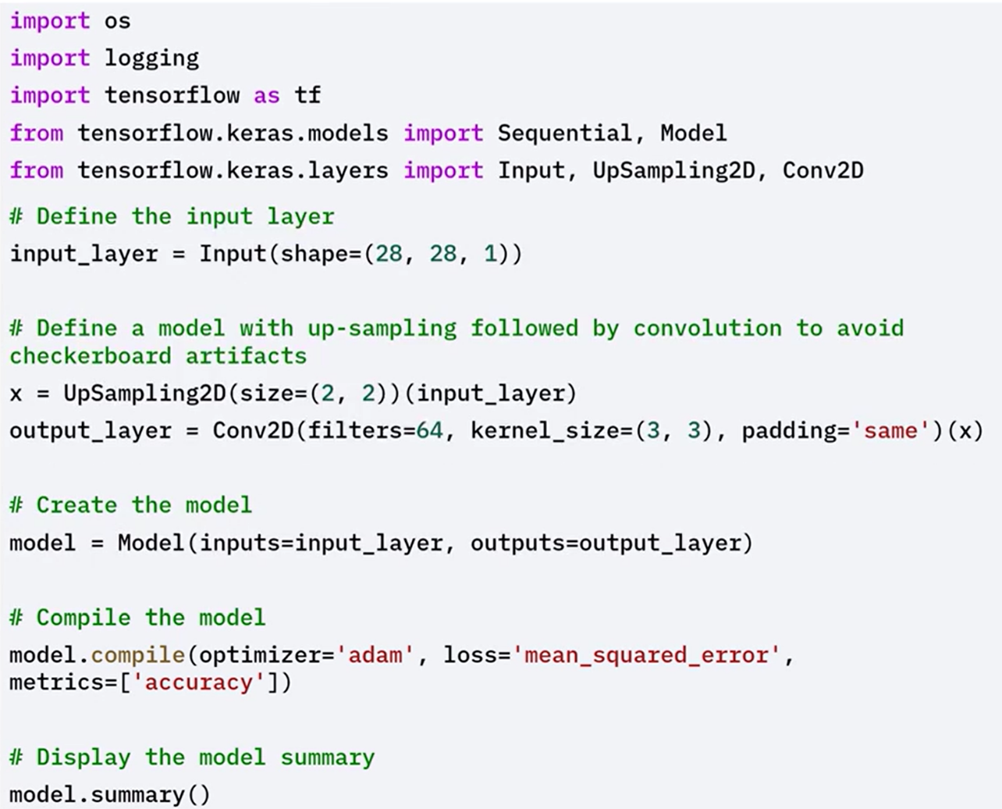

Involves taking a **pre-trained model**, such as VGG16 trained on ImageNet, and adapting it to a new dataset.

The idea is to reuse the **feature extraction layers** (like convolutional layers) while customizing the final layers for the new task.

Enables **faster convergence**, **higher accuracy**, and **training on smaller datasets**.

**Why use Transfer Learning?**

* **Reduced Training Time**:  
  The model already learned general visual features (edges, textures, shapes), so training starts from a strong baseline.
* **Improved Performance**:  
  Pre-trained models, optimized on large datasets, tend to generalize better on smaller ones.
* **Works Well with Small Datasets**:  
  Even with limited data, transfer learning achieves high accuracy because the model retains useful pre-learned features.

These advantages make it suitable for domains like **medical imaging** or **natural language processing**, where labeled data is scarce or expensive

### ✅ Takeaways

✅ Transpose convolution is used to **up-sample** feature maps in tasks such as image generation, super-resolution, and segmentation.

✅ It works by **inserting zeros** into the input feature map and applying convolution to increase spatial dimensions.

✅ Keras provides native support for this through layers like Conv2DTranspose.

✅ **Checkerboard artifacts** are a common issue, and can be mitigated by combining **UpSampling2D** with a **Conv2D** layer.

✅ Transpose convolution enables models to perform **pixel-level reconstruction** and generate higher-resolution outputs, which are essential for many image processing applications.